UNIQUE PLACES:-

# REWARI RAILWAY HERITAGE MUSEUM:-

The **Rewari Railway Heritage Museum** (formerly the **Rewari Steam Locomotive Shed**) is a c.1893 [railway museum](https://en.wikipedia.org/wiki/Railway_museum) in [Delhi NCR](https://en.wikipedia.org/wiki/Delhi_NCR) at [Rewari](https://en.wikipedia.org/wiki/Rewari" \o "Rewari) city in [Haryana](https://en.wikipedia.org/wiki/Haryana), [India](https://en.wikipedia.org/wiki/India). Built in 1893, it is the only surviving [steam locomotive](https://en.wikipedia.org/wiki/Steam_locomotive) shed in India, and houses some of India's last surviving steam locomotives as well as the world's oldest still-functional 1855-built steam locomotive the [Fairy Queen](https://en.wikipedia.org/wiki/Fairy_Queen_(locomotive)). It is located 400 m (1,300 ft) north of the entrance of the [Rewari railway station](https://en.wikipedia.org/wiki/Rewari_railway_station" \o "Rewari railway station), 50 km (31 mi) from [Gurgaon](https://en.wikipedia.org/wiki/Gurgaon" \o "Gurgaon) and 79 km (49 mi) from the [National Rail Museum](https://en.wikipedia.org/wiki/National_Rail_Museum,_New_Delhi) at [Chanakyapuri](https://en.wikipedia.org/wiki/Chanakyapuri" \o "Chanakyapuri) in [New Delhi](https://en.wikipedia.org/wiki/New_Delhi).[[1]](https://en.wikipedia.org/wiki/Rewari_Railway_Heritage_Museum#cite_note-1)

KEY HOLDING :- REWARI QUEEN

The shed and compound has 11 (of 16 functional in India)[[7]](https://en.wikipedia.org/wiki/Rewari_Railway_Heritage_Museum" \l "cite_note-7) of the world's oldest steam locomotives,[[*citation needed*](https://en.wikipedia.org/wiki/Wikipedia:Citation_needed)] restored and still functional, including the following:[[8]](https://en.wikipedia.org/wiki/Rewari_Railway_Heritage_Museum#cite_note-et1-8)

* **Baldwin AWE**, built by the American company [Baldwin Locomotive Works](https://en.wikipedia.org/wiki/Baldwin_Locomotive_Works) in 1945[[9]](https://en.wikipedia.org/wiki/Rewari_Railway_Heritage_Museum#cite_note-9)
* **Akbar WP1761**, named after the [Mughal Emperor](https://en.wikipedia.org/wiki/Mughal_Empire" \o "Mughal Empire), [Akbar](https://en.wikipedia.org/wiki/Akbar), built in 1963 at [Chittranjan Locomotive Works](https://en.wikipedia.org/wiki/Chittranjan_Locomotive_Works" \o "Chittranjan Locomotive Works) was inducted into active service in 1965. It has [4-6-2](https://en.wikipedia.org/wiki/4-6-2) wheel arrangement, 5 ft 6 in (1,676 mm) gauge and 110 km/h (68 mph) maximum speed now-restricted to 45 km/h (28 mph) The locomotive was based at [Saharanpur](https://en.wikipedia.org/wiki/Saharanpur) railway shed after being retired from active service and it has been restored and housed at Rewari shed.[[10]](https://en.wikipedia.org/wiki/Rewari_Railway_Heritage_Museum#cite_note-runaway1-10)[[11]](https://en.wikipedia.org/wiki/Rewari_Railway_Heritage_Museum#cite_note-dna1-11)[[12]](https://en.wikipedia.org/wiki/Rewari_Railway_Heritage_Museum#cite_note-ut1-12) It is now used to power the 150UP Delhi Cantt – Alwar Steam Express heritage train.[[13]](https://en.wikipedia.org/wiki/Rewari_Railway_Heritage_Museum#cite_note-up150-13)
* **Shahanshah**[**WP/P**](https://en.wikipedia.org/wiki/Indian_locomotive_class_WP), is one of the original bullet-nosed American [Baldwin prototype number 7200 Shahanshah](https://en.wikipedia.org/wiki/Baldwin_Locomotive_Works), which was at the [Charbagh workshops](https://en.wikipedia.org/wiki/Lucknow_Charbagh_railway_station" \o "Lucknow Charbagh railway station) in [Lucknow division](https://en.wikipedia.org/wiki/Lucknow_NR_railway_division" \o "Lucknow NR railway division). It was restored for use in steam specials by the [Northern Railway](https://en.wikipedia.org/wiki/Northern_Railway_zone). It has also run several steam specials, including one between [Royapuram](https://en.wikipedia.org/wiki/Royapuram_railway_station" \o "Royapuram railway station) and [Tambaram](https://en.wikipedia.org/wiki/Tambaram_railway_station" \o "Tambaram railway station) on 26 January 2009, to commemorate the 153rd anniversary of [Royapuram railway station](https://en.wikipedia.org/wiki/Royapuram_railway_station" \o "Royapuram railway station) (built 1856), the oldest railway station in India. It ran the Steam Express on 14 January 2012. The engine is considered a lucky mascot for the film shoots and is rented out at INR4 lakhs (INR400,000 or US$6,150) a day.[[8]](https://en.wikipedia.org/wiki/Rewari_Railway_Heritage_Museum#cite_note-et1-8)[[14]](https://en.wikipedia.org/wiki/Rewari_Railway_Heritage_Museum#cite_note-ut2-14)

he museum is open daily.[[17]](https://en.wikipedia.org/wiki/Rewari_Railway_Heritage_Museum#cite_note-mk1-17) It has a 3-D steam loco simulator simulating [Darjeeling Himalayan Railway steam locomotive](https://en.wikipedia.org/wiki/Darjeeling_Himalayan_Railway) ride, 3-D virtual reality coach simulator, a toy train, educational yard model train system, indoor exhibition gallery, a 35-seater conference room with projector, a century-old dining car, cafeteria and souvenir shop. In the museum, there are exhibit halls showing [models of small engines](https://en.wikipedia.org/wiki/Rail_transport_modelling), old railway equipment, [hand-held brass signal lamps](https://en.wikipedia.org/wiki/Carbide_lamp), and old photos. The facilities at museum include 30 minute long documentaries and films shows, once or twice a day in museum's conference hall with seating capacity of 50, about the history and present operations of railways in India.[[16]](https://en.wikipedia.org/wiki/Rewari_Railway_Heritage_Museum#cite_note-toi1-16)

[Fairy Queen](https://en.wikipedia.org/wiki/Fairy_Queen_(locomotive)) steam-locomotive ferries tourists from Delhi to Rewari every second Saturday from October to April.[[15]](https://en.wikipedia.org/wiki/Rewari_Railway_Heritage_Museum#cite_note-dev1-15)

The Rewari Steam Locomotive Shed was refurbished as a [heritage tourism](https://en.wikipedia.org/wiki/Heritage_tourism) destination, its edifice restored, and a museum added by the Indian Railways in December 2002.[[4]](https://en.wikipedia.org/wiki/Rewari_Railway_Heritage_Museum#cite_note-Ministry_of_Railways-4) The shed exhibited [Victorian era](https://en.wikipedia.org/wiki/Victorian_era) artifacts used on the Indian rail network, along with the old signalling system, [gramophones](https://en.wikipedia.org/wiki/Phonograph), and seats. The refurbished heritage museum was opened in October 2010. The engines are still available for live demonstrations.[[2]](https://en.wikipedia.org/wiki/Rewari_Railway_Heritage_Museum#cite_note-bl-2)[[5]](https://en.wikipedia.org/wiki/Rewari_Railway_Heritage_Museum#cite_note-5)[[6]](https://en.wikipedia.org/wiki/Rewari_Railway_Heritage_Museum#cite_note-6)

The Rewari steam locomotive shed has rented locomotives for various film shoots and part of the film [*Gandhi, My Father*](https://en.wikipedia.org/wiki/Gandhi,_My_Father) was shot here.[[2]](https://en.wikipedia.org/wiki/Rewari_Railway_Heritage_Museum#cite_note-bl-2)[[18]](https://en.wikipedia.org/wiki/Rewari_Railway_Heritage_Museum#cite_note-18) Locomotives have appeared in films such as *[Barfi!](https://en.wikipedia.org/wiki/Barfi!" \o "Barfi!)*, [*Guru*](https://en.wikipedia.org/wiki/Guru_(2007_film)), [*love aaj kal*](https://en.wikipedia.org/w/index.php?title=Love_aaj_kal&action=edit&redlink=1), [*Rang De Basanti*](https://en.wikipedia.org/wiki/Rang_De_Basanti) and [Veer-Zaara](https://en.wikipedia.org/wiki/Veer-Zaara) among others.[[19]](https://en.wikipedia.org/wiki/Rewari_Railway_Heritage_Museum#cite_note-ie1-19) The locomotive *Akbar* has featured in several movies shot here, including: [*sultan*](https://en.wikipedia.org/wiki/Sultan), *[Gadar: Ek Prem Katha](https://en.wikipedia.org/wiki/Gadar:_Ek_Prem_Katha" \o "Gadar: Ek Prem Katha)*, [*Gandhi, My Father*](https://en.wikipedia.org/wiki/Gandhi,_My_Father), *[Ki & Ka](https://en.wikipedia.org/wiki/Ki_%26_Ka" \o "Ki & Ka)*, [*Sultan (2016 film)*](https://en.wikipedia.org/wiki/Sultan_(2016_film)), [*Gangs of Wasseypur (film series)*](https://en.wikipedia.org/wiki/Gangs_of_Wasseypur_(film_series)), *[Qarib Qarib Singlle (2017 film)](https://en.wikipedia.org/wiki/Qarib_Qarib_Singlle" \o "Qarib Qarib Singlle)*, [*Partition (2007 film)*](https://en.wikipedia.org/wiki/Partition_(2007_film)), *[Pranayam](https://en.wikipedia.org/wiki/Pranayam" \o "Pranayam)* (2011 Malayalam movie), *[Ek Tha Chander Ek Thi Sudha](https://en.wikipedia.org/wiki/Ek_Tha_Chander_Ek_Thi_Sudha" \o "Ek Tha Chander Ek Thi Sudha)* (TV serial)[[10]](https://en.wikipedia.org/wiki/Rewari_Railway_Heritage_Museum#cite_note-runaway1-10)

UPTO HERE <https://en.wikipedia.org/wiki/Rewari_Railway_Heritage_Museum>

In 2012, the first commercial run of a heavy steam engine by the railways took place after a gap of 16 years.  
  
The engine for the run, too, was chosen after much deliberation. "It is a 1965-make WP class engine manufactured by Chittaranjan locomotives and decommissioned even before the Saharanpur loco shed shut down in 1987. A Pacific class model with a 4-6-2 wheel formation, it has 1,460 horsepower. It can touch 110kmph and was used to haul the fastest Express trains during its heyday," Vikas Arya, the then senior divisional mechanical engineer (power), Northern Railway had said.

UPTO HERE :- <https://economictimes.indiatimes.com/infrastructure/rewari-locomotive-the-only-steam-loco-shed-that-remains-in-india/2012-first-commercial-run-after-16-years/slideshow/21137879.cms>

# PHOTOS ;-

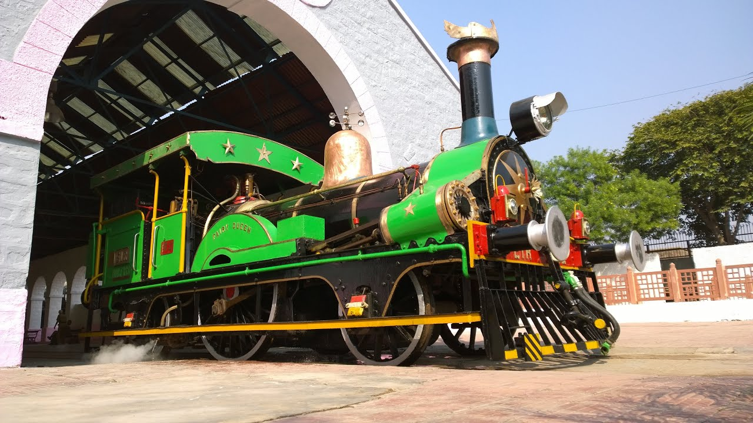

src - <https://i.ytimg.com/vi/J2mBlVz8Chc/maxresdefault.jpg>

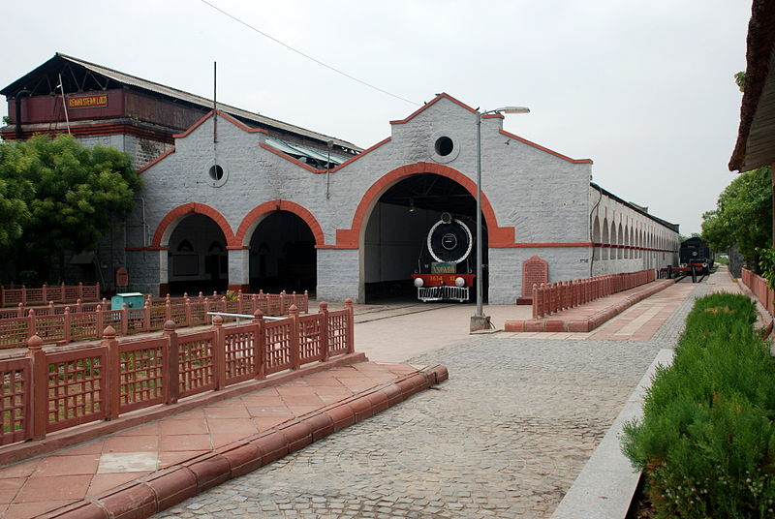

Src - <https://commons.wikimedia.org/wiki/File:Rewari_Railway_Heritage_Museum.JPG>

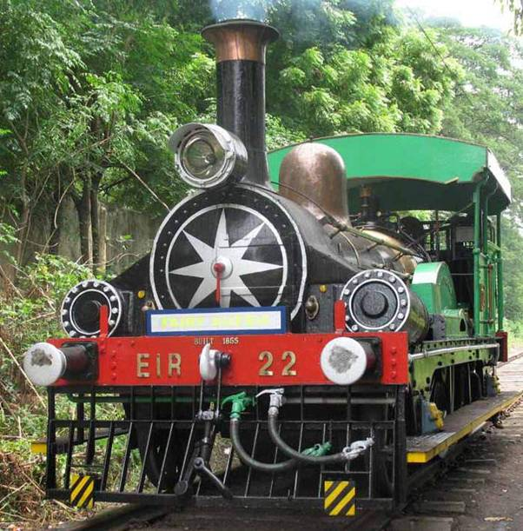

<https://namastenewsline.com/2017/02/10/worlds-oldest-working-steam-engine-fairy-queen-ready-to-haul-heritage-train-once-again/>

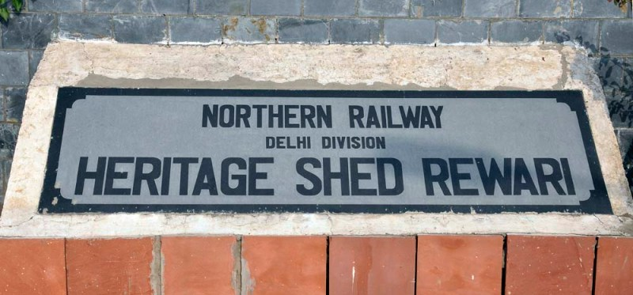

Src:- <https://monvoyage.in/>

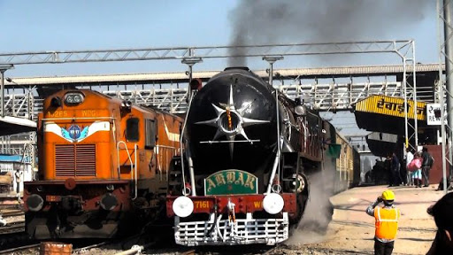

src - https://lh3.googleusercontent.com/proxy/e-6b9Qj0yY8GE1StiDCAC\_GTUfR0JFUGW3IU8JuaCWSnte4zadzY6mSzxTbJgF57VnP\_V1EFegwcvWtTFn9pcfLtQuIUrBTGMUgav3j3CiopjJse9xdNC\_7AVdajvvzvd4qNuUAoxZPx

# DIAMOND CROSSING NAGPUR:-

# 

1. A Diamond Crossing in railroad phrasing is where two railroad lines cross (not really at right edges, framing the state of diamonds at the intersection point. People often wonder how many diamond crossing in India and while they are rare, one of them is super popular. They are all amazingly unusual but the most renowned one is the Diamond Crossing Nagpur which is a Double Diamond Railway crossing shaped by two twofold lines crossing one another.
2. A number of people have been said about this specific point, as the point where lines from the North, South, East and West meet and furthermore, even as the centre point of India! It is simple for such things to flourish, particularly since the use of the Internet.
3. In the first place, just three remarkable rail lines meet at the diamond railway crossing Nagpur. One originates from the east, from Gondia, the Howrah – Rourkela – Raipur line. Alternate originates from the north, from [**New Delhi**](https://www.adotrip.com/city-detail/delhi). The last one goes towards the South, carrying trains to both the west and the south. This line divides into two separate lines toward the west ([**Mumbai**](https://www.adotrip.com/city-detail/mumbai)) and the South (Kazipet) just at Wardha, approximately 80 km away. Also, just a single of these lines structures some portion of the jewel crossing, the Gondia line.

.

.

1. The British considered Nagpur as the geographic centre point of united India and raised the zero-mile marker there, however, once India was partitioned this moved and now according to official records, the centre point of India lies in a forest somewhere close to Jabalpur. This town "Karondi" lies is closest to it.
2. Presently, railroad wise, the "actual" point where the North, East, South and West of India meet is at Itarsi Junction rail route station, MP. Lines from the North (towards [**Agra**](https://www.adotrip.com/city-detail/agra) – Delhi), South (towards Nagpur), East ([**Jabalpur**](https://www.adotrip.com/city-detail/jabalpur) – Allahabad and after that Howrah) and West (Khandwa – Mumbai) meet at Itarsi. It is equally "focus ish" to India, so guess, that will do.
3. Upto here <https://www.adotrip.com/blog/do-you-know-what-makes-the-diamond-crossing-special-know-the-incredible-charm>

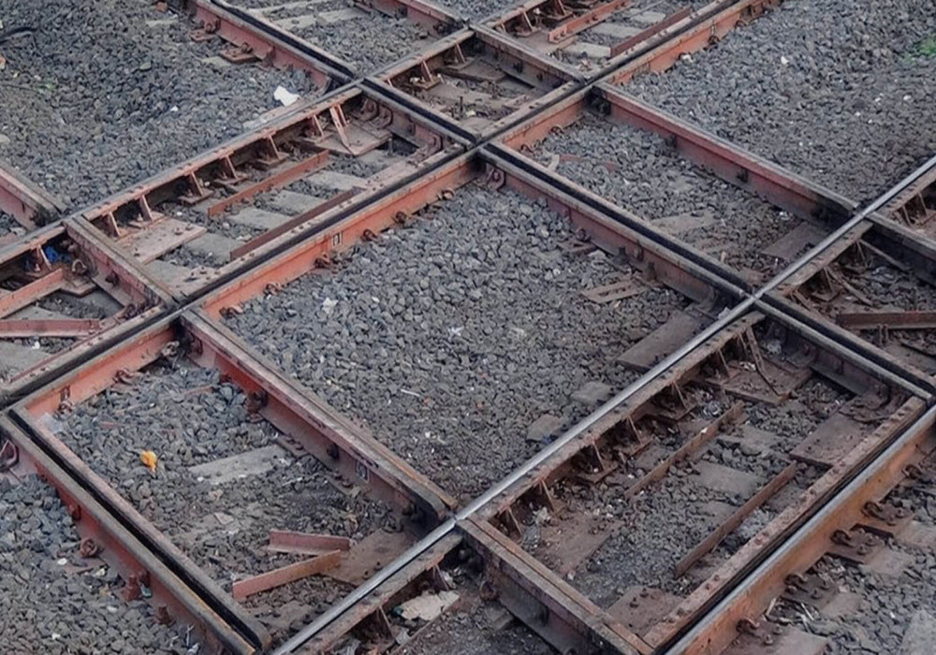

<https://www.adotrip.com/public/images/blogs/master_images/5c615707e9d41-Diamond_Crossing_Nagpur_India2.jpg>

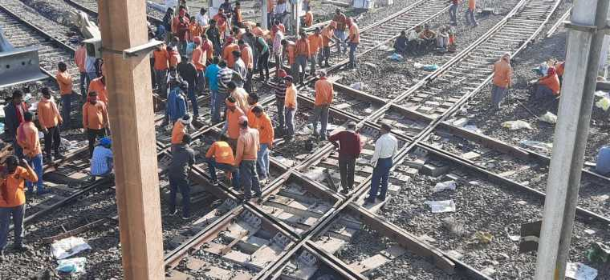

<https://i1.wp.com/www.railpost.in/wp-content/uploads/2020/01/NGP-diamond-1.jpg?resize=1024%2C472&ssl=1>

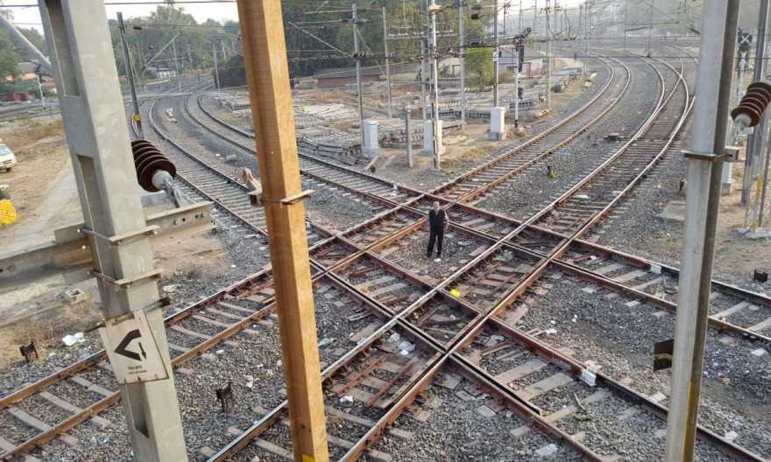

<https://i2.wp.com/www.railpost.in/wp-content/uploads/2020/01/NGP-Diamond-2.jpg?resize=880%2C528&ssl=1>

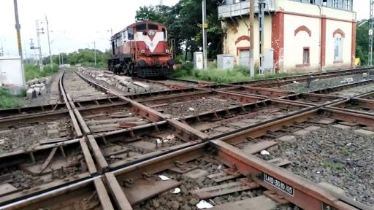

Src- <https://lh3.googleusercontent.com/proxy/oWMr-XPWueQtDT0gjRLpnzOQv9JkUkC0bnI1qp3SvyFPksXcBvsotTCZoJ9fd9U64Or9xMbwqPtHzoptdtAA14ZDU52UNMyRtVyxAnVynW_nA0IhC5PvqeRVVKqwpfCPW0OJieTL0-Z4V-y0>

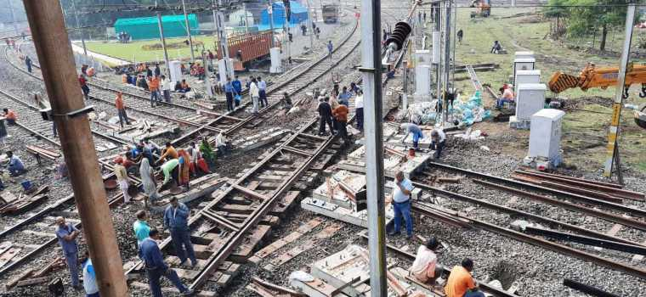

Src - <https://i2.wp.com/www.railpost.in/wp-content/uploads/2020/01/NGP-Diamond-3.jpg?fit=760%2C350&ssl=1>

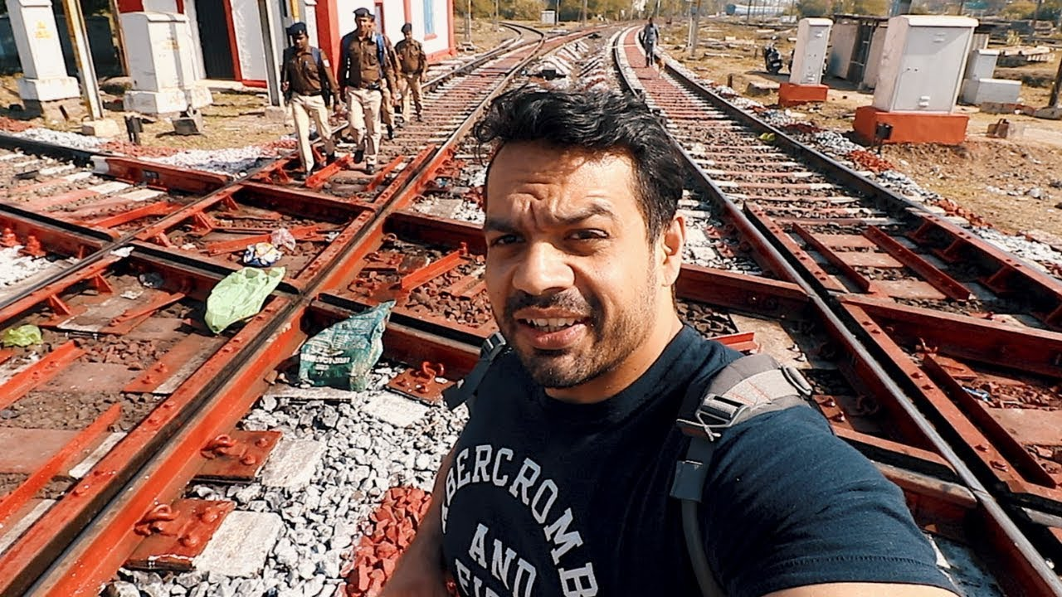

Src - <https://i1.wp.com/i.ytimg.com/vi/eNxQSx0JDMo/maxresdefault.jpg?ssl=1>

# RANI KI VAV :-

1. ***Rani ki Vav*** or ***Ranki vav*** (lit. '**Queen’s stepwell**') is a [stepwell](https://en.wikipedia.org/wiki/Stepwell" \o "Stepwell) situated in the town of [Patan](https://en.wikipedia.org/wiki/Patan,_Gujarat" \o "Patan, Gujarat) in [Gujarat](https://en.wikipedia.org/wiki/Gujarat) state of [India](https://en.wikipedia.org/wiki/India). It is located on the banks of [Saraswati river](https://en.wikipedia.org/wiki/Saraswati_River,_Gujarat" \o "Saraswati River, Gujarat). Its construction is attributed to Udayamati, daughter of [Khengara](https://en.wikipedia.org/wiki/Khengara" \o "Khengara) of Saurashtra, queen of the 11th-century [Solanki dynasty](https://en.wikipedia.org/wiki/Solanki_dynasty" \o "Solanki dynasty) and spouse of [Bhima I](https://en.wikipedia.org/wiki/Bhima_I" \o "Bhima I). Silted over, it was rediscovered in 1940s and restored in 1980s by the [Archaeological Survey of India](https://en.wikipedia.org/wiki/Archaeological_Survey_of_India). It has been listed as one of [UNESCO's World Heritage Sites](https://en.wikipedia.org/wiki/UNESCO_World_Heritage_Sites_in_India) since 2014.
2. The finest and one of the largest examples of [its kind](https://en.wikipedia.org/wiki/History_of_stepwells_in_Gujarat) and designed as an inverted temple highlighting the sanctity of water, the stepwell is divided into seven levels of stairs with sculptural panels; more than 500 principal sculptures and over a thousand minor ones combine religious, mythological and secular imagery.
3. Rani ki vav was constructed during the rule of the [Chaulukya dynasty](https://en.wikipedia.org/wiki/Chaulukya_dynasty" \o "Chaulukya dynasty). It is located on the banks of [Saraswati river](https://en.wikipedia.org/wiki/Saraswati_River,_Gujarat" \o "Saraswati River, Gujarat).[[1]](https://en.wikipedia.org/wiki/Rani_ki_vav#cite_note-:4-1) *[Prabandha-Chintamani](https://en.wikipedia.org/wiki/Prabandha-Chintamani" \o "Prabandha-Chintamani)*, composed by the Jain monk [Merutunga](https://en.wikipedia.org/wiki/Merutunga" \o "Merutunga) in 1304, mentions: "Udayamati, the daughter of Naravaraha Khengara, built this novel stepwell at Shripattana (Patan) surpassing the glory of the [Sahastralinga Tank](https://en.wikipedia.org/wiki/Sahastralinga_Tank" \o "Sahastralinga Tank)". According to it, the stepwell was commissioned in 1063 and was completed after 20 years. It is generally assumed that it was built in the memory of [Bhima I](https://en.wikipedia.org/wiki/Bhima_I" \o "Bhima I) (r. c. 1022 – 1064) by his queen Udayamati and probably completed by Udayamati and [Karna](https://en.wikipedia.org/wiki/Karna_(Chaulukya_dynasty)" \o "Karna (Chaulukya dynasty)) after his death but the view, whether she was a widow when she commissioned it, is disputed. Commissariat puts the date of construction to 1032 based on the architectural similarity to [Vimalavasahi temple on Mount Abu](https://en.wikipedia.org/wiki/Dilwara_Temples" \o "Dilwara Temples) built in the same year.[[2]](https://en.wikipedia.org/wiki/Rani_ki_vav#cite_note-:3-2)[[3]](https://en.wikipedia.org/wiki/Rani_ki_vav#cite_note-:0-3)[[4]](https://en.wikipedia.org/wiki/Rani_ki_vav#cite_note-4)
4. The stepwell was later flooded by the nearby Saraswati river and silted over.[[5]](https://en.wikipedia.org/wiki/Rani_ki_vav#cite_note-:6-5) In 1890s, Henry Cousens and [James Burgess](https://en.wikipedia.org/wiki/James_Burgess_(archaeologist)) visited it when it was completely buried under the earth and only well shaft and few pillars were visible. They called it huge pit measuring 87 metres (285 ft). In *Travels in Western India,* [James Tod](https://en.wikipedia.org/wiki/James_Tod) mentioned that the material from the stepwell was reused in the other stepwell built in modern Patan, probably Trikam Barot ni Vav (Bahadur Singh stepwell).[[6]](https://en.wikipedia.org/wiki/Rani_ki_vav#cite_note-:5-6)[[7]](https://en.wikipedia.org/wiki/Rani_ki_vav#cite_note-:7-7) In 1940s, the excavations carried out under the [Baroda State](https://en.wikipedia.org/wiki/Baroda_State) revealed the stepwell. In 1986, the major excavation and restoration was carried out by the [Archaeological Survey of India](https://en.wikipedia.org/wiki/Archaeological_Survey_of_India) (ASI). An image of Udayamati was also recovered during the excavation. The restoration was carried out from 1981 to 1987.[[2]](https://en.wikipedia.org/wiki/Rani_ki_vav#cite_note-:3-2)[[5]](https://en.wikipedia.org/wiki/Rani_ki_vav#cite_note-:6-5)
5. Rani ki vav is declared the Monument of National Importance and protected by the ASI. It was added to the list of [UNESCO's World Heritage Sites](https://en.wikipedia.org/wiki/UNESCO_World_Heritage_Sites_in_India) on 22 June 2014.[[8]](https://en.wikipedia.org/wiki/Rani_ki_vav#cite_note-:1-8)[[9]](https://en.wikipedia.org/wiki/Rani_ki_vav#cite_note-:2-9) It was named India's "Cleanest Iconic Place" at the 2016 Indian Sanitation Conference.[[10]](https://en.wikipedia.org/wiki/Rani_ki_vav#cite_note-10)
6. Rani ki vav is considered as the finest and one of the largest example of stepwell architecture in Gujarat. It was built at the height of craftsmens’ ability in stepwell construction and the [Maru-Gurjara architecture](https://en.wikipedia.org/wiki/Maru-Gurjara_architecture" \o "Maru-Gurjara architecture) style, reflecting mastery of this complex technique and beauty of detail and proportions. The architecture and sculptures is similar to the [Vimalavasahi temple on Mount Abu](https://en.wikipedia.org/wiki/Dilwara_Temples" \o "Dilwara Temples) and [Sun temple at Modhera](https://en.wikipedia.org/wiki/Sun_Temple,_Modhera).[[2]](https://en.wikipedia.org/wiki/Rani_ki_vav#cite_note-:3-2)
7. It is classified as a *Nanda*-type stepwell. It measures approximately 65 metres (213 ft) long, 20 metres (66 ft) wide and 28 metres (92 ft) deep. The fourth level is the deepest and leads into a rectangular tank 9.5 metres (31 ft) by 9.4 metres (31 ft), at a depth of 23 metres (75 ft). The entrance is located in the east while the well is located at the westernmost end and consists of a shaft 10 metres (33 ft) in diameter and 30 metres (98 ft) deep.[[1]](https://en.wikipedia.org/wiki/Rani_ki_vav#cite_note-:4-1)[[2]](https://en.wikipedia.org/wiki/Rani_ki_vav#cite_note-:3-2) The stepwell is divided into seven levels of stairs which lead down to deep circular well. A stepped corridor is compartmentalized at regular intervals with pillared multistory pavilions. The walls, pillars, columns, brackets and beams are ornamented with carvings and scroll work. The niches in the side walls are ornamented with beautiful and delicate figures and sculptures. There are 212 pillars in the stepwell.[[2]](https://en.wikipedia.org/wiki/Rani_ki_vav#cite_note-:3-2)
8. There are more than 500 principle sculptures and over a thousand minor ones combine religious, mythological and secular imagery, often referencing literary works.[[1]](https://en.wikipedia.org/wiki/Rani_ki_vav#cite_note-:4-1) The ornamentation of stepwell depicts the entire universe inhabited by gods and goddesses; celestial beings; men and women; monks, priests and laity; animals, fishes and birds including real and mythical ones; as well as plants and trees.[[2]](https://en.wikipedia.org/wiki/Rani_ki_vav#cite_note-:3-2)[[7]](https://en.wikipedia.org/wiki/Rani_ki_vav#cite_note-:7-7)
9. The stepwell is designed as an underground shrine or inverted temple. It has spiritual significance and represents the sanctity of water.[[1]](https://en.wikipedia.org/wiki/Rani_ki_vav#cite_note-:4-1) The sculptures in stepwell depicts numerous Hindu deities including [Brahma](https://en.wikipedia.org/wiki/Brahma), [Vishnu](https://en.wikipedia.org/wiki/Vishnu), [Shiva](https://en.wikipedia.org/wiki/Shiva), goddesses ([*Devi*](https://en.wikipedia.org/wiki/Devi)), [Ganesha](https://en.wikipedia.org/wiki/Ganesha), [Kubera](https://en.wikipedia.org/wiki/Kubera), [Lakulisha](https://en.wikipedia.org/wiki/Lakulisha), [Bhairava](https://en.wikipedia.org/wiki/Bhairava), [Surya](https://en.wikipedia.org/wiki/Surya), [Indra](https://en.wikipedia.org/wiki/Indra) and [Hayagriva](https://en.wikipedia.org/wiki/Hayagriva). The sculptures associated with Vishnu outnumbers all which include Sheshashayi Vishnu (Vishnu reclined on thousand hooded snake [Shesha](https://en.wikipedia.org/wiki/Shesha" \o "Shesha) in the celestial ocean), Vishwarupa Vishnu (Cosmic form of Vishnu), twenty four forms as well as [Dashavatara](https://en.wikipedia.org/wiki/Dashavatara" \o "Dashavatara) (ten incarnations) of Vishnu.[[2]](https://en.wikipedia.org/wiki/Rani_ki_vav#cite_note-:3-2)[[6]](https://en.wikipedia.org/wiki/Rani_ki_vav#cite_note-:5-6)
10. The sculptures of deities with their families such as Brahma-Savitri, Uma-Maheshwar and Lakshmi-Narayan are there. Notable among other sculptures are [Ardhanarishwara](https://en.wikipedia.org/wiki/Ardhanarishvara" \o "Ardhanarishvara) as well as large number of goddesses such as [Lakshmi](https://en.wikipedia.org/wiki/Lakshmi), [Parvati](https://en.wikipedia.org/wiki/Parvati), [Saraswati](https://en.wikipedia.org/wiki/Saraswati), [Chamunda](https://en.wikipedia.org/wiki/Chamunda), [Durga](https://en.wikipedia.org/wiki/Durga)/Mahishasurmardini with twenty hands, Kshemankari, Suryani and [Saptamatrikas](https://en.wikipedia.org/wiki/Matrikas" \o "Matrikas). There are images of [Navagraha](https://en.wikipedia.org/wiki/Navagraha" \o "Navagraha) (nine plantets) as well.[[2]](https://en.wikipedia.org/wiki/Rani_ki_vav#cite_note-:3-2)[[6]](https://en.wikipedia.org/wiki/Rani_ki_vav#cite_note-:5-6)
11. There are large number of sculptures portraying women in their everyday life and activities. One sculpture depicts a woman combing her hair, adjusting her earring and looking herself in the mirror. Another sculptures include a woman writing a letter, a young woman with scorpion climbing her right leg and her clothes sliding off unknowingly, a young woman pulling a beard of a dwarf-like man, a woman with fish plate in her hands with a snake encircling her leg and reaching out to fish. One sculpture depicts a young women coming out of bath with her wet hair and a swan catching droplets of water falling from her hairs as if they are pearls. These women sculptures are adorned with jewelry including bangles, earrings, necklaces, waist girdles, anklets and others as well as with elegant clothes and well combed hairs. The variety of expressions and emotions are depicted in them. They represent beauty as well love in its sublime and seductive form signaling eroticism. There are sculptures representing maternal love such as a woman holding her child and pointing to moon to divert his attention, a woman raising her child high to let him pick a mango from tree, a woman in a mango grove with children with her.[[2]](https://en.wikipedia.org/wiki/Rani_ki_vav#cite_note-:3-2)

Uptohere ­:- <https://en.wikipedia.org/wiki/Rani_ki_vav>

Rani (Queen) Udayamati commissioned this vav or stepwell, in 1063 in the memory of her husband King Bhimdev I of the Solanki dynasty. The vav was later flooded by the nearby Saraswati river and silted over until the late 1980s, when it was excavated by the Archeological Survey of India, with the carvings found in pristine condition. Rani Ki Vav is amongst the finest stepwells in India, and one of the most famous legacies of the ancient capital city.

The vavs of Gujarat are not merely sites for collecting water and socialising, but also simultaneously hold great spiritual significance. They were originally constructed quite simply, but became more intricate over the years, perhaps to make explicit this ancient concept of the sanctity of water by carving it out in stone deities. You may thus enter Rani Ki Vav as if it is a subterranean temple.

The steps begin at ground level, leading you down through the cool air through several pillared pavilions to reach the deep well below. There are more than 800 elaborate sculptures among seven galleries. The central theme is the Dasavataras, or ten incarnations of Vishnu, including Buddha. The avatars are accompanied by sadhus, brahmins, and apsaras (celestial dancers), painting their lips and adorning themselves. At water level you come to a carving of Sheshashayi-Vishnu, in which Vishnu reclines on the thousand-hooded serpent Shesha, where it is said he rests in the infinity between ages.

Upto here :\_ <https://www.gujarattourism.com/destination/details/6/61>

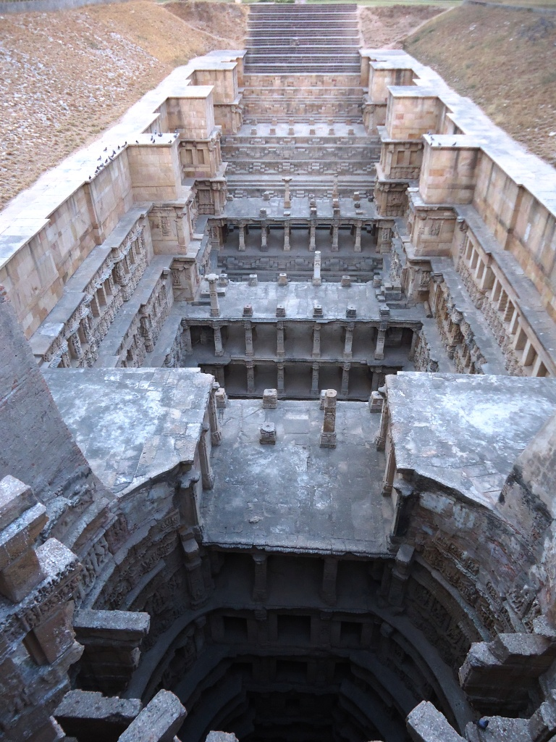<https://upload.wikimedia.org/wikipedia/commons/4/4e/Rani_Ki_Vav%2C_Above_View.JPG>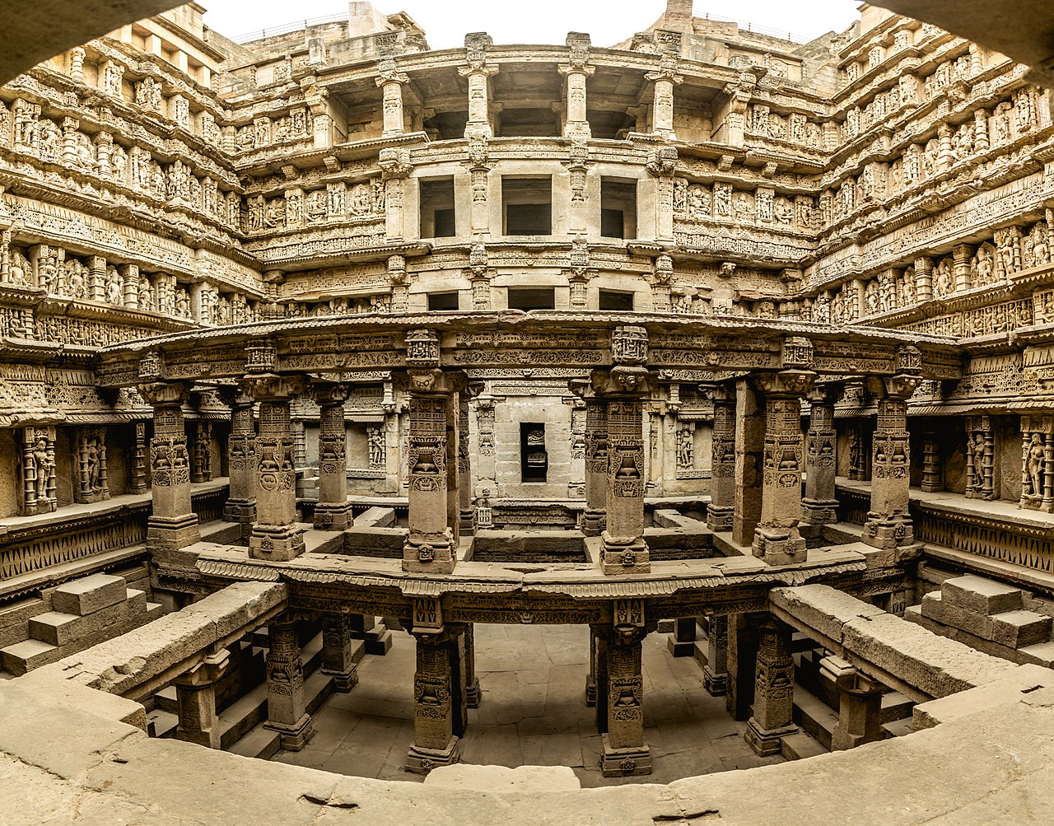

<https://upload.wikimedia.org/wikipedia/commons/thumb/1/14/Rani_ki_vav1.jpg/1280px-Rani_ki_vav1.jpg>

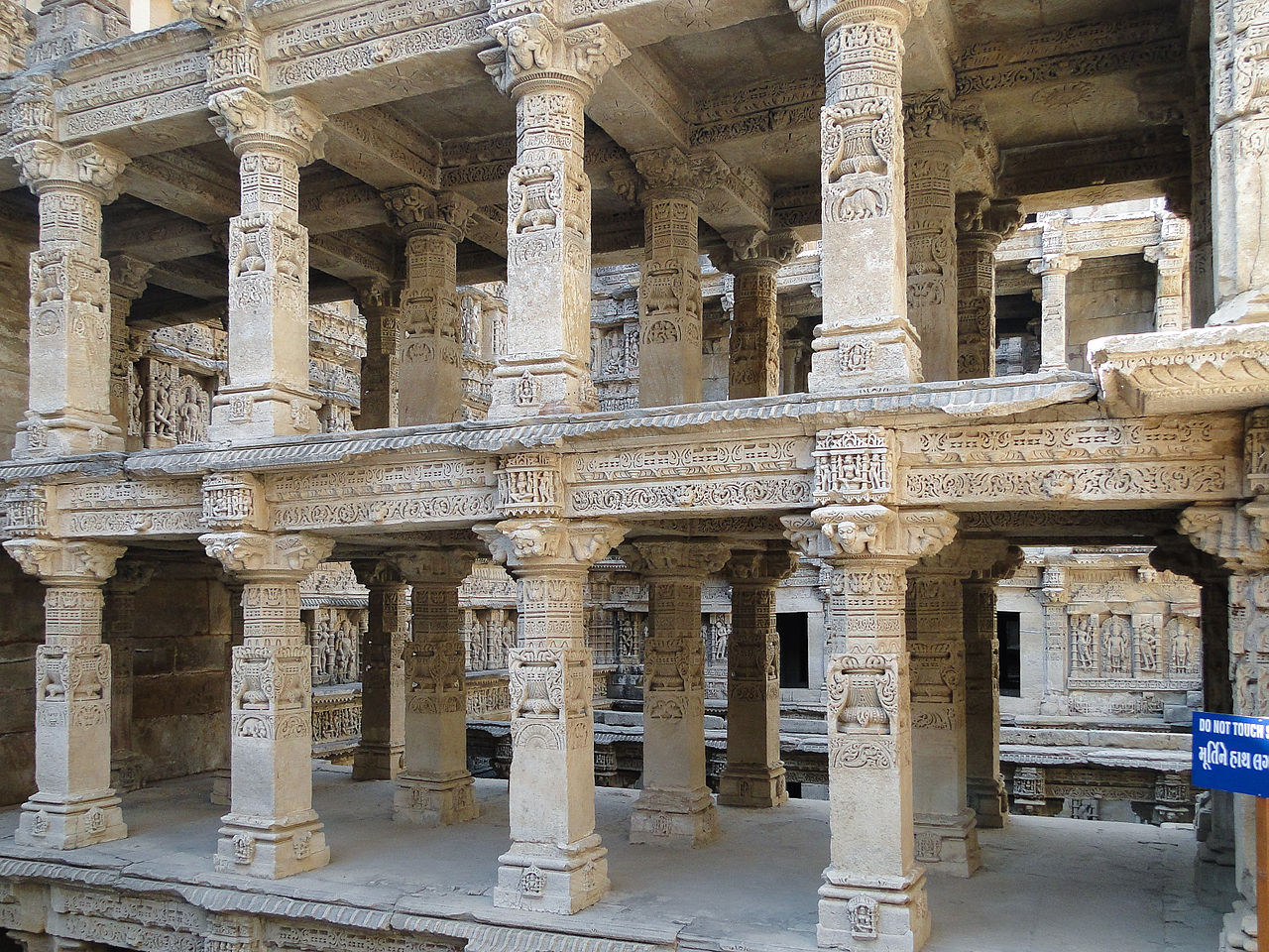

<https://upload.wikimedia.org/wikipedia/commons/thumb/e/e7/Rani_ki_vav_08.jpg/1280px-Rani_ki_vav_08.jpg>

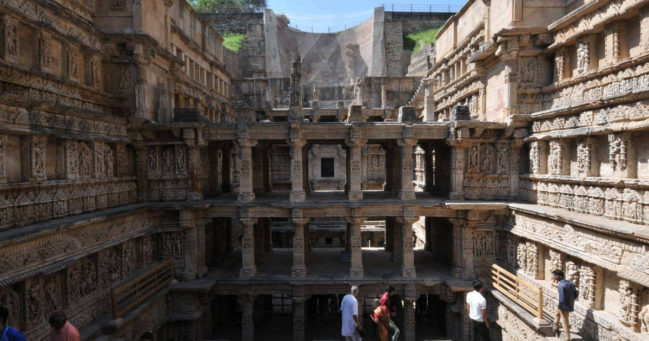

<https://whc.unesco.org/uploads/thumbs/site_0922_0002-1200-630-20140622130343.jpg>

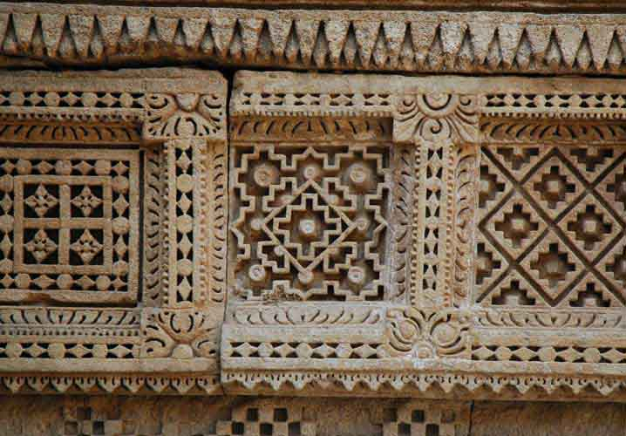

Src - <https://www.gujarattourism.com/destination/details/6/61>

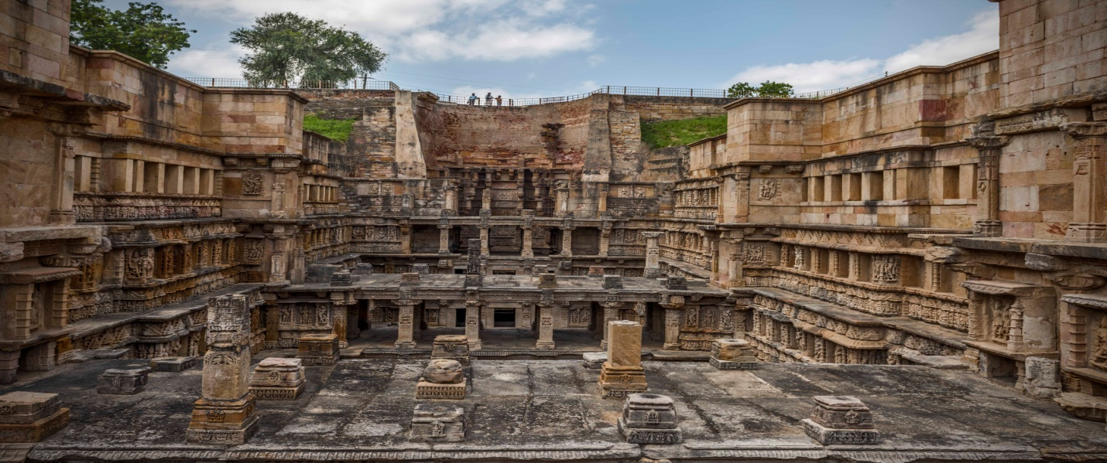

<https://www.gujarattourism.com/destination/details/6/61>